STAIRS
Def. A stair is a means of providing access from one floor level to another. Its primary functions are;
[i] Establish a safe means of travel between floor levels.
[ii] Provide an easy means of travel between floor levels.
[ii] Provide a means of conveying fittings and furniture between floor levels.

Terminologies
- Stairwell –the space in between the walls where the stairs and the landing are housed.
- Stair – the actual means of ascension or descension from one level to another.
- Tread – the upper surface of a step on which the foot is placed.
- Nosing – the exposed edge of a tread, usually projecting with a square rounded or splayed edge.
- Riser – the vertical member between two consecutive treads.
- Step – rise + tread
- Going –the horizontal distance between two consecutive risers as defined in the Kenya building code. The distance measured on plan between two consecutive nosing.
- Rise – the vertical height between two consecutive treads.
- Flight – a series of steps without a landing.
- Newel – post forming the junction of flight of stairs with landings or carrying the lower end of strings.
- String – the member receiving the end of the steps which are generally housed to the string and secured by wedges to the walls or outer string according to their position.
- Handrail – a projecting member usually paralleled to the string and spanning between newels. This could be attached to a wall above and paralleled to a string.
- Baluster – the vertical infill member between a string and handrail.
- Pitch line – a line connecting the nosing of all treads in anyone flight.

BUILDING REGULATIONS [HI] FOR DWELLING HOUSES.
These regulations deals with only two types of stairs i.e.
[i] Common stairway
[ii] Private stairway
Common stairway
This is an internal or external stairway of steps with straight nosing’s on plan which forms part of building and is intended for common use in connection with two or more dwellings.
Private stairway
This is an internal or external stairway of steps with straight nosing’s on plan which forms part of building and is either within a dwelling or intended for use solely in connection with one dwelling.
Types of stairs
Stairs are classified according to:
[i] Plan form
[ii] Construction
[iii] Material
The three basic ways in which the stairs are planned is:
[i] Straight flight stairs
[ii] Quarter turn stairs
[iii] Half turn stairs

Straight flight stair
A straight flight stair rises from one floor to another without any change of direction, with or without a landing.
Quarter turn stair
A quarter turn stair rises to a landing between floors, turns 90º and then rises to the floor above.
Half turn stair
Half turn stair rises to a landing between floors, turns 180º then rises parallel to the lower flight to the floor above. It can be arranged with no space between the flights or with a space or well between them.

DESIGN OF STAIRS
Slope or pitch
The dimensions of the rise and going of its steps determine whether a stair is steep or shallow.
Example; a rise of 75mm and a going of 300mm makes the stair shallow while a rise of 225mm and a going of 100mm will make it steep.
Nb: a shallow stair occupies more space on plan and thus reduces living area.
Width
In most cases it will be necessary to allow sufficient width for two persons to pass, which requires a minimum width of 1100mm. For domestic stairs a minimum width of 765mm is accepted.
Flights
Long flights of stairs without landings as points of rest can be dangerous especially when used by children or elderly people as a means of escape. Twelve steps in a flight is usually taken as a maximum [depends on the pitch]
An absolute maximum are sixteen and a minimum three steps in a flight.
Landing
Usually a landing should not be shorter in direction of travel than the width of stair. a good rule is to make the landing longer than this by at least the width of one tread. The absolute minimum is 690mm for dwellings and 915mm for public houses.
Headroom
The headroom can be sometimes a problem in stair design. The minimum height according to Kenya building code [KBC] is 2060mm for dwellings and 2140mm for public houses.

INSITU REINFORCED CONCRETE STAIRS
These are non-combustible, strong and hardwearing. concrete specification is usually 1:2;4/20mm aggregate with a cover of concrete over reinforcement of 15mm minimum or the bar diameter whichever is greater.
The thickness of concrete required is dependent on the loading and span but is not generally less than 100mm or more than 150mm measured across the waist i.e. distance from the soffit to the intersection of tread and riser.
Handrails and balustrades must be made of non combustible material, being placed continuous on both sides if the width of the stairs exceeds 1.060m. The overall height of the handrail up the stairs should be between 840 and 915mm measured vertically and have a height above the floor between 1.070 and 1.090m.The capping can be made of combustible materials such as plastic provided that it is fixed to over a non combustible core.
A wide variety of finishes can be applied to the tread surface of the stairs. I.e. carborundum dust to provide a hardwearing non-slip surface, PVC tiles, rubber tiles, natural cement mortar finishes and carpet mats applied and fixed in the same manner as for floors.
NB: in all cases, the stairs must comply the minimum requirements set out in part K of the building regulations in accordance with the purpose of the building in which the stairs are situated.
Spiral and helical stairs
Spiral stairs are those that describe a helix around a central column whereas a helical stair has an open well. The open well of a helical stair is usually circular or elliptical in plan and the formwork is built up around a vertical timber core.
Spiral stairs are considered to be aesthetically pleasing but are expensive. They are confined mainly to prestige buildings usually as accommodation stairs linking floors within the same compartment

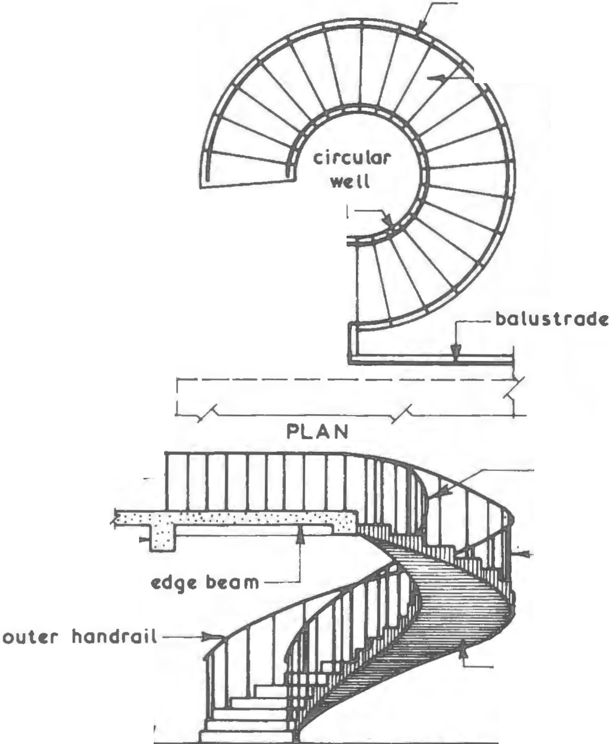

PRECAST CONCRETE STAIRS
The design considerations is the same as for Insitu concrete stairs but the fixing and support require a different approach. Bearings for the ends of the flights must be provided at the floor or landing levels in the form of haunch, rebate or bracket and continuity of reinforcement is achieved by leaving projecting bars and slots in the floor into which they can be grouted.
During delivery, the stairs should be lifted, positioned and fixed direct from the delivery vehicle thus avoiding double handling. NB: care must be exercised during lifting since introduction of unacceptable stresses may lead to cracking/damage of the units.
The stair surfaces should be covered by non-slip vinyl floor finishes which are applied to treads, risers and landings with aluminium nosing’s screwed and plugged to the treads and safety inserts placed into the aluminium nosing.
The use of precast concrete stairs is limited to situations such as short flights between changes in floor level and external stairs to basements and other areas. They rely on loadbearing wall for support and if cantilevered, on the downward load of the wall to provide the equal supporting reaction.

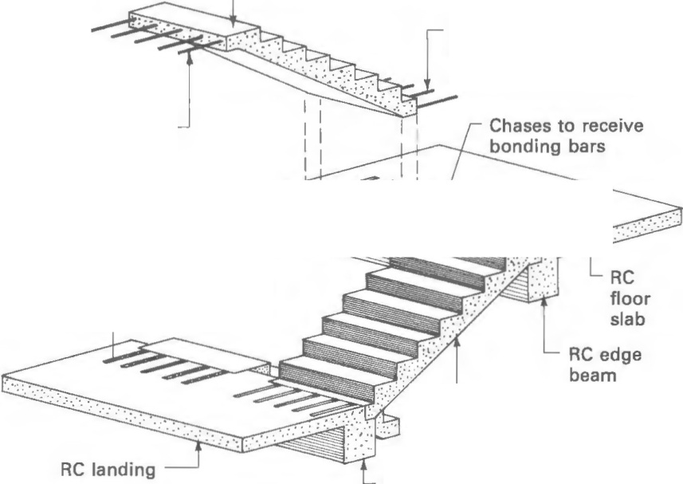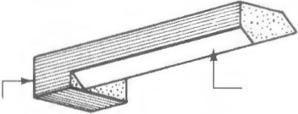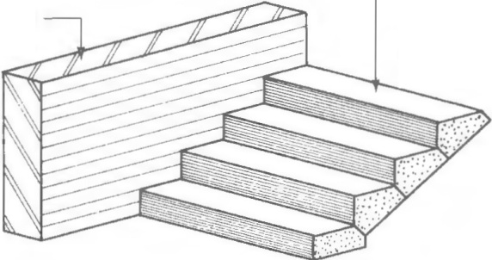

RC edge beam

Cantilever step
support wall Precast concrete cantilever steps
Built into wall forming stairs

Simple precast concrete steps

Precast concrete spiral stairs
usually constructed with an open riser format using tapered treads which have a keyhole plan shape.
Advantages of precast concrete stairs
- Good quality control of the finished product
- Saves site space since no formwork fabrication and storage is required.
- Faster speed of construction
- Hoisting, positioning and fixing can usually be carried out by semi-skilled labour.
- Sound reduction.

TIMBER STAIRS
The dimension of the treads and risers should be kept constant throughout any flight of steps to reduce the risk of accidents by changing the rhythm of movement up or down the stairway. The height of individual step rise is calculated by dividing the total rise by the chosen no of risers. The step going is chosen to suit the floor area available so that it, together with the rise meets the requirements of building regulations.
NB: in any one flight there will be one more riser than treads since the last tread is the landing.
Stairs are constructed by joining the steps into the spanning members or strings by using housing joints, glueing and wedging the steps into position to form a complete and rigid joint. Small angle blocks can be glued at the junction of the tread and riser in a step to reduce the risk of slight movement giving rise to the annoyance of creaking. The flight can be given extra rigidity by using triangular brackets placed under the steps on the centre line of the flight.
Stairs are designed to be either fixed to a wall with one outer string, fixed between walls or freestanding- the majority have one wall string and one outer string. The wall string is fixed directly to the wall along its entire length, or is fixed to timber battens plugged to the wall, the top of the string being cut and hooked over the trimming member of the stairwell. The outer string is supported at both ends by a newel post, in the case of the bottom newel, this rests on the floor. In the upper newel, it is notched over and fixed to the stairwell trimming member.

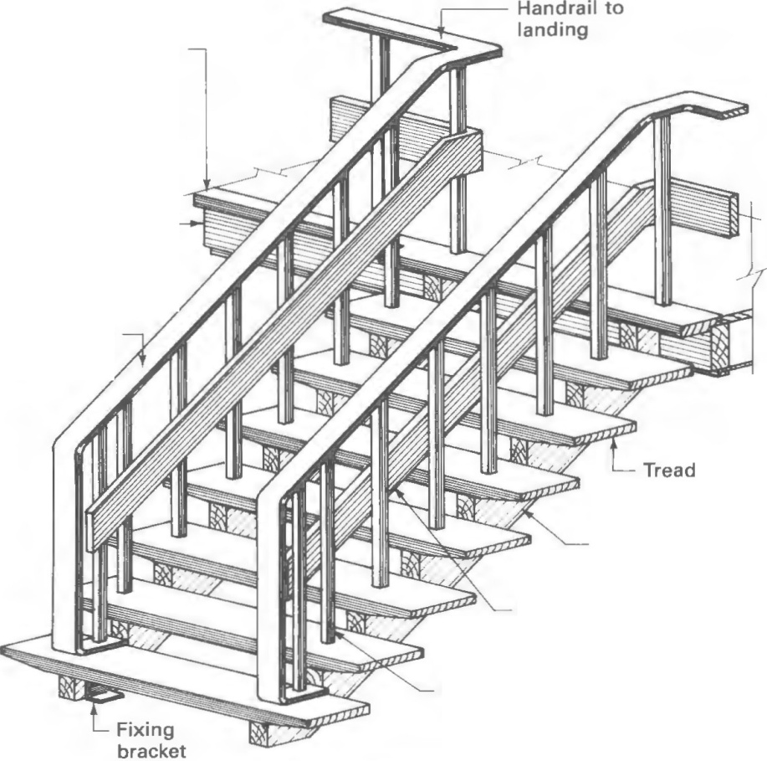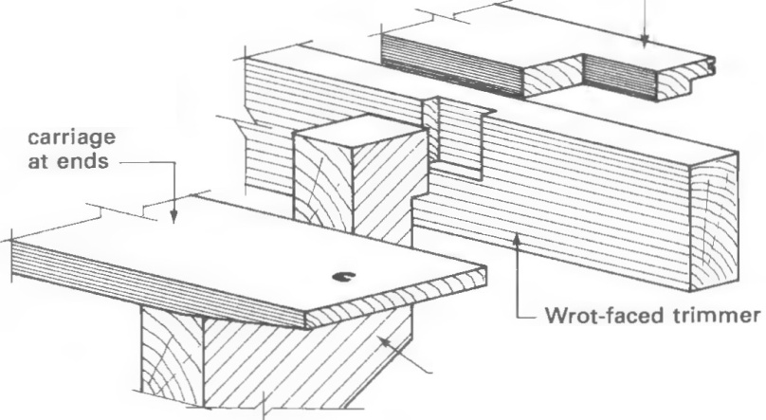Stepped rebated
Nosing

Wrot-faced
Trimmer

Cut string or carriage
Timber knee board
Metal standards or balusters

Cut string open – tread stairs

Min going + twice rise= 550
100x100 Newel post

Easing to take bottom edge of riser

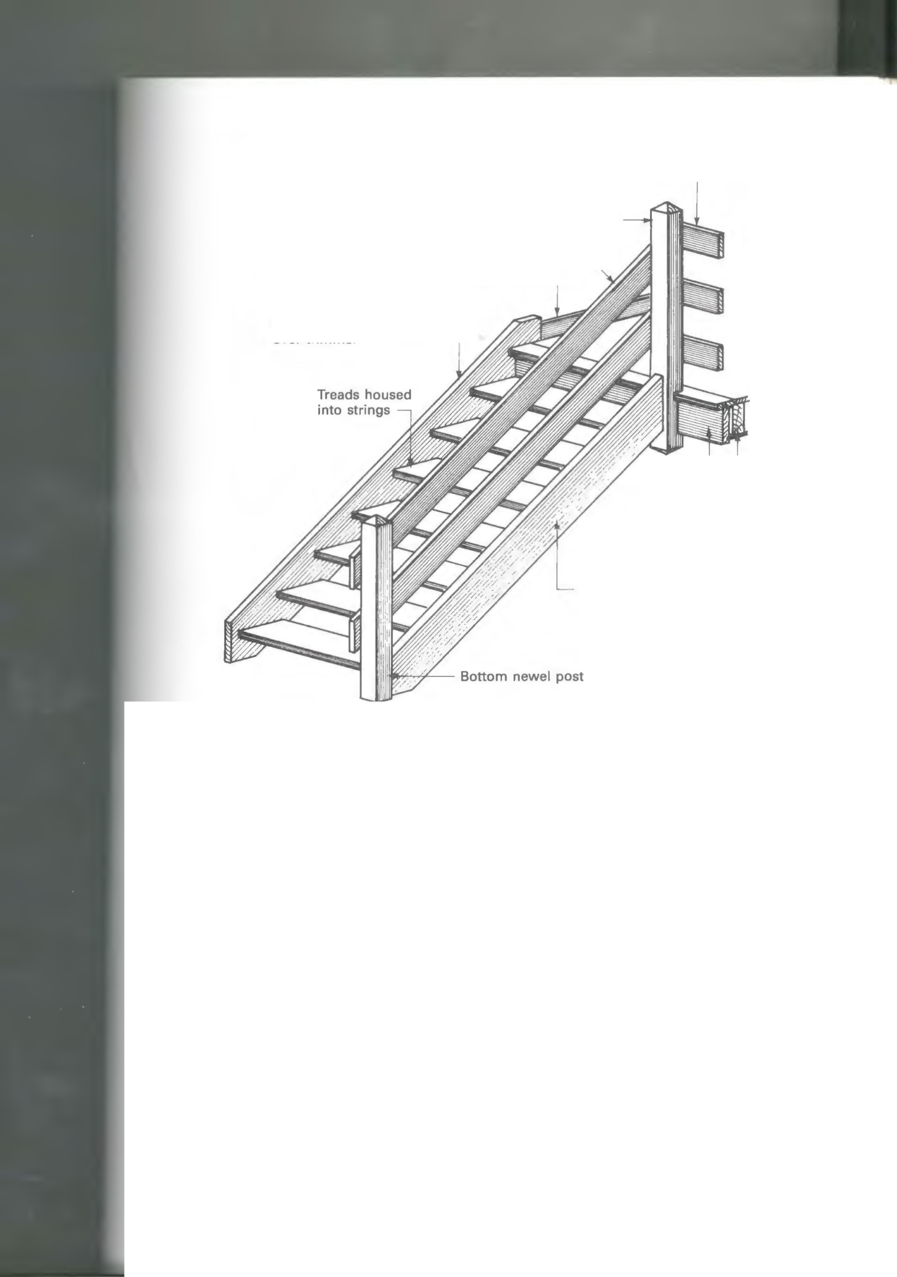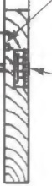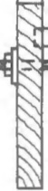

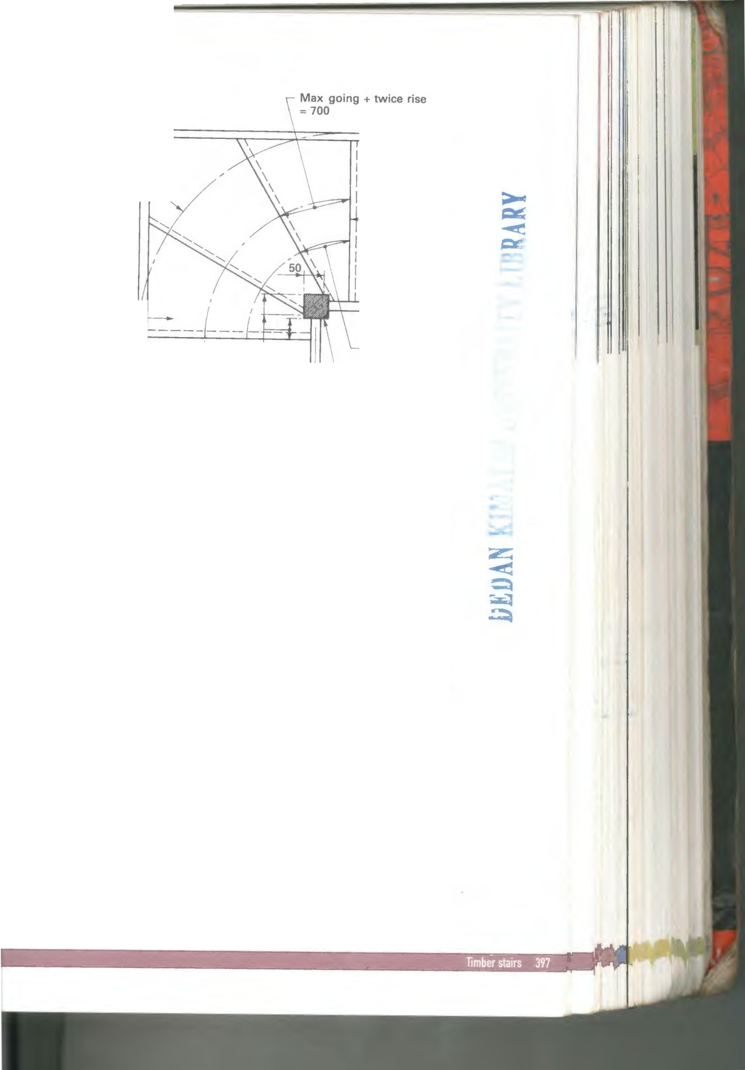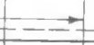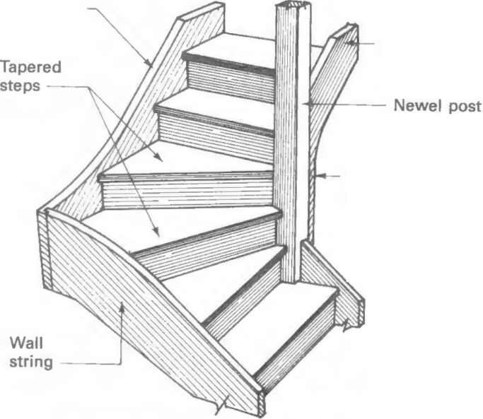

Tapered steps (or winders) for private stairways

METAL STAIRS
Materials used for metal stairs construction include: Cast iron, mild steel or aluminium alloy. Metal stairs are mostly used as escape stairs or for internal accommodation stairs. There is a requirement for them to comply with building regulations for general stair construction and also for fire escape stairs.
They are purpose made and hence they are costly compared to concrete stairs. The advantage of metal stairs is the elimination of the need for formwork while they have a disadvantage of regular maintenance inform of painting required for cast iron and mild stairs

Typical Example – Straight Flight Steel External Escape Stair

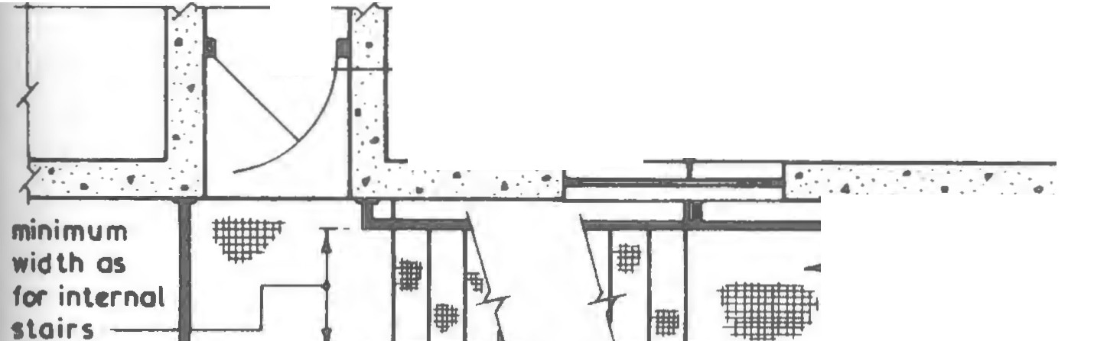

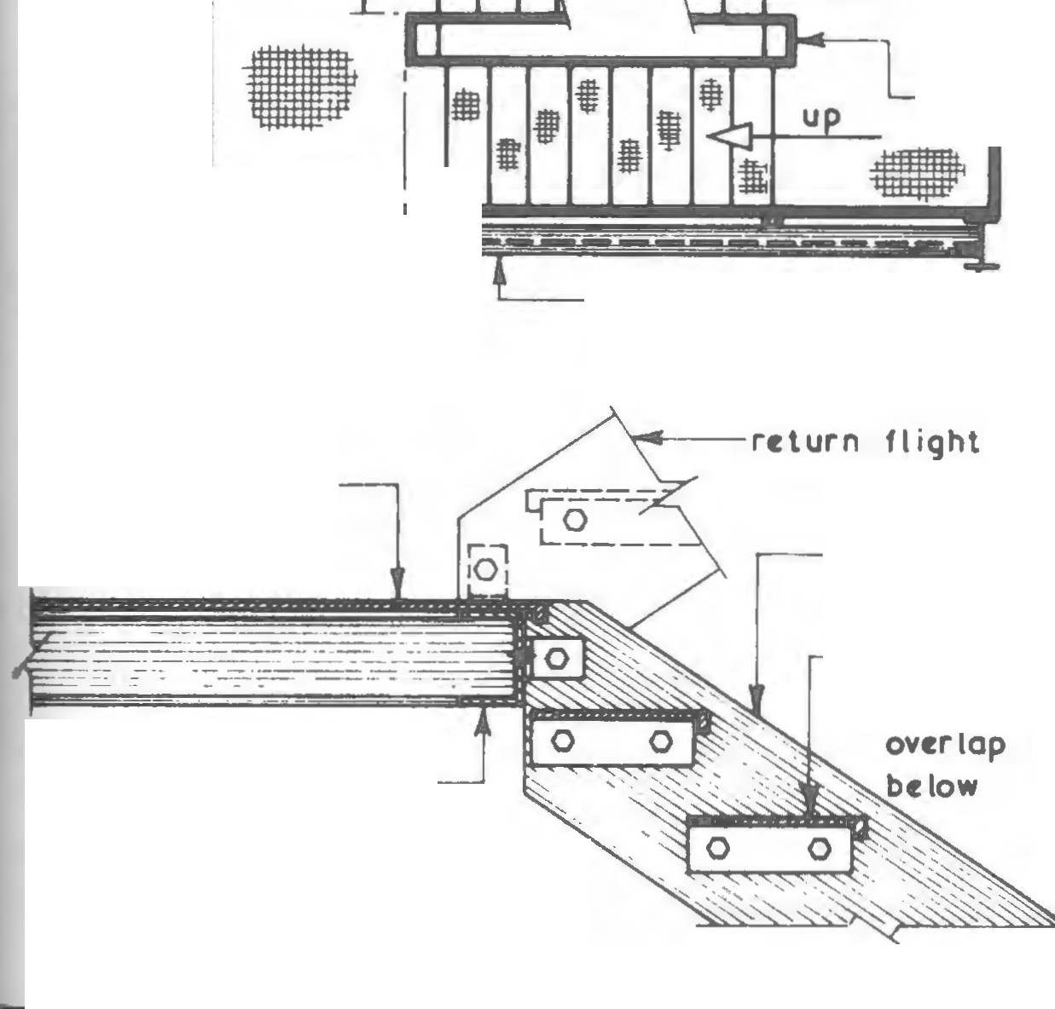

---++.....,.+ door to open in
direct ion a but
.•
c lear
of
st air s
windows within 1·800
horizontally or vertically up or 9·000 down to be f ixed and 1/2 hr. f.r.
landi ng
width nol less than
stair widt.._--
-
-
-- ------....
support
column
.a.. steel plated
landings on framed steel channels
. _._ continuous
handra ils 900mm min. above pitch line
universal
beam at
PLAN
each f loor leve l
support
column
prr forated
plates to
stul
landing
s trings
out of
framed s teel channels
forming landing suppor t handrai I omillord for c larit y
LANDING JUNCT ION DE TAIL
m i Id stul plate
per forated s tul treads with 25 mm
of tread

DRAINAGE
Def: It is a system of pipes, generally underground used to convey the discharge from the roofs, paved areas and sanitary fittings to a point of discharge or treatment.
PRINCIPLES OF A GOOD DRAINAGE SYSTEM
[i] The materials used should have adequate strength and durability for their location.
[ii] The diameter of the drains should be as small as practicable. i.e. for soil drains, the minimum diameter allowed is 100mm while for surface water, the minimum diameter is 75mm. generally 100mm branch and 150mm main runs are used.
[iii] All parts of a drain should be accessible for the purpose of inspection, maintenance and cleaning.
[iv] As far as possible, the drains should be laid in straight runs to avoid issues with bends.
[v] Drains must be laid to a gradient that renders it self cleansing. The fall or gradient is calculated based on the rate of flow, the velocity required and the diameter of the drain. Maguire’s rule of the thumb can be used to give a reasonable velocity. In this rule the gradient is arrived at by dividing the pipe diameter in millimetres by 2.5 i.e. a pipe of 100mm will have a fall of 1 in 40. The velocity of flow should be at least 0.75m/s.
Building regulations approved document H also provides tables to accommodate this.
[vi] every drain inlet should be trapped to prevent the entry of foul air into the building. The minimum seal required is 50mm. table 1 of building regulations approved document H also provides details on trap sizes.
[vii] rodding access points should be located at the head or start of each drain run.
[viii] Inspection chambers, manholes, rodding eyes or access fittings should be placed at changes of direction and gradient if the changes prevents the drain from easy cleansing.
They must also be placed at a junction, change of drainpipe size and at every 90 metres straight run.
[ix] Drains should also not be placed under foundations since the load over them can interfere with their integrity but in instances when it is unavoidable, then they should be covered with concrete.

DRAINAGE SYSTEMS [SCHEMES]
The plan layout depends upon a number of factors i.e,
(i) No of discharge points connecting to the drain
(ii)Relative positions of the discharge points
(iii)Drainage system and location of the local authority sewers
(iv) Internal layout of sanitary fittings
(v)External positions of rainwater pipes
(vi)Functions of buildings connecting to drain system
(vii)Topography of the area to be served
COMBINED SYSTEM OF DRAINAGE
It is the simplest and least expensive since all drains discharge into a common or combined sewer. In this system there is no duplication of drains. This system has the advantage of easy maintenance, all drains are flushed during the rains and it is also impossible to connect to the wrong sewer. The disadvantage with this method is that all the discharges must pass through the sewage treatment installation which could be costly and prove to be difficult with periods of heavy rain when the surface water run-off to the sewer s at maximum.
Insert the sketch here.
TOTALLY SEPARATE SYSTEM OF DRAINAGE
This is the most common form of drainage. In this system, two sewers are used. One sewer receives surface water and conveys the same to a suitable outfall such as a river while the other sewer receives soil/foul discharge from baths, basins, sinks, showers and toilets and conveys the same to a sewage treatment installation.
In this system, more drains are required, there is the risk of connecting to the wrong sewer, the soil drains are not flushed during heavy rains but the savings on treatment of a small volume of discharge is preferred by the local authorities.
Insert the sketch here.

PARTIALLY SEPARATE SYSTEM OF DRAINAGE
This is a compromise between the other two systems. It is favored by local authorities because of its flexibility. In it there are two sewers, one to convey surface water and another combined sewer to convey the total foul discharge and a proportion of the surface water. The amount of surface water to be discharged into the combined sewer can be adjusted according to the capacity of the sewerage installation.
Insert the sketch here.

Materials for drainage
Drainage pipes are considered as either rigid or flexible. Clay is an example of rigid pipes while unplasticised pvc pipes is an example of flexible pipes.
Inspection chamber
These provide a means of access to drainage systems and contain facilities for a few junctions and branch connections. They are used up to an invert depth not exceeding 1metre. Materials used for their construction include plastics, clay, bricks and precast concrete
The size of an inspection chamber depends on the depth to invert level, drain diameter and the number of branch drains to be accommodated within the chamber.
Insert the sketch here.
Manhole
These are means of access to drains and sewers and are called so if the depth of the invert level exceeds 1metre. It is a compartment containing half or three quarter section round channels to enable the flow to be observed and to provide a drain access point for cleansing and testing. It should comply with the access recommendations of approved document H.
Insert the sketch here.
NB: The student to check on drain bending details. Soakaways and cess pools

WATER SUPPLY
An adequate supply of water is a basic requirement for most buildings for use as drinking water, hygiene and other activities such as cooking and manufacturing process. Water extracted from surface storage reservoirs or rivers or boreholes should be filtered, chlorinated to kill bacteria, aerated and treated with fluoride before distribution through a system of water mains under pressure for human consumption.
The water mains are laid underground at a considerable depth to protect them from frost or traffic movement. The trunk mains of the pipework feeds a grid of subsidiary mains for distribution to specific areas/districts. Materials used for main pipes are cast iron and uPVC.
Terminologies
- Main- a pipe for general conveyance of water as distinct from the conveyance to individual premises
- Service- a system of pipes and fittings for the supply and distribution of water in any individual premises.
- Service pipe- a pipe in service that is directly subject to pressure from a main sometimes called the rising main inside the building.
- Communication pipe- that part of the service pipe that is owned by the water authority.
- Distribution pipe –any pipe in a service conveying water from a storage cistern.
- Cistern – a container of water in which the stored water is under atmospheric pressure.
- Storage cistern - any other cistern other than a flushing cistern.
- Tank – a rectangular vessel completely closed and used to store water.
- Cylinder –a closed cylindrical tank.

Cold water supply
Outside the boundary, the water company should provide a communication pipe to a stop valve and surface box. A service pipe is connected to the stop valve to an internal stop valve within the property. The stop valve should have a drain-off valve in it to enable draining off the service pipe or rising main.
Service pipes should be protected against frost, heavy traffic or building loads. A pedestrian footpath is an ideal location for the water mains supply pipework. A minimum of 750mm is recommended for domestic properties supply. Where a pipe passes under abuilding, it should be housed in a protective duct or pipe suitably insulated within 750mm of the floor level.

Insert the sketch here

Direct cold water supply
The service pipe supplies cold water directly to the sanitary fittings and taps. This system is ideal where large high-level reservoirs are able to provide a good mains supply and high pressure. In this system, only a small cold water storage cistern to feed the hot water tank may be required.
The cistern can be positioned below the ceiling level within an airing cupboard and hence saves on pipe runs to the roof space and eliminates the need to insulate the pipes against frost. This system also has an advantage in that fresh drinking water is available from several outlets.
Disadvantages
- Lack of reserve water in case the mains supply is cut off during repair works.
- Low pressure during peak demand periods
- Risk of contamination of the mains by back-siphonage as a result of sanitary fittings being connected to the mains supply. This occurs if there is negative pressure on the mains and any of the outlets are submerged below the water level such as hand spray connected to the taps.

Insert the sketch here

Indirect cold water supply
This system comprises of a cold water storage cistern positioned at a high level usually in the roof space from where all the sanitary fittings are supplied from. An exception to this supply is the drinking water outlet at the sink.
This system gives a reserve supply in case of mains failure and reduces the risk of contamination by back siphonage, however, it requires more pipework. When used in a block of flats, a sufficient – sized storage tank and its loadings need to be accommodated.
Insert the sketch here

Hot water supply
Hot water supplied to domestic sanitary fittings is usually taken from a hot water tank or cylinder or from a combination boiler. The source of heat could be inform of gas, oil, solid-fuel boiler, back boiler to an open fire or electric immersion heater fixed into the hot water storage tank. Two systems are used to heat water in the tank i.e. Direct and indirect systems.
Direct hot water system
In this system, cold water flows through the water jacket in the boiler and its temperature is raised by combustion of the fuel and convection currents are induced which causes the water to rise and circulate around the system. The hot water which leaves the boiler is replaced by cold water descending from the hot water cylinder by gravity thus setting up the circulation.
Hot water cylinder should be insulated to avoid excessive heat loss and lower hot water temperatures. This system has disadvantage relating to its suitability for supplying a central heating circuit. In hard water areas, the pipes and cylinder will become furred with lime deposits as a result of precipitation of lime when water is heated between 50-70ºc. This building up of lime deposits may eventually block the pipework.

Insert the sketch here

Indirect hot water system
This system was designed to overcome the problems of furring characterized by direct hot water supply system. The system is suitable for hard water areas and in all systems where a central heating circuit is to be part of the hot water installation.
The pipe layouts of the two systems are similar but in this system, a separate small capacity feed cistern is required to charge and top up the primary circuit and boiler for initial supply or top up due to evaporation.
The cylinder in this system is different from that of direct hot water supply. The difference is in the design. In this system, the hot water storage tank or cylinder is a heat exchanger through the use of a closed – loop system. The cylinder contains a coil or annulus connected to the flow and return pipes from the boiler. The transfer of heat to the water stored within the cylinder takes place within the cylinder.
Insert the sketch here
Cisterns
These are fixed containers used for storing water at atmospheric pressures. The inflow is controlled by a float valve which is adjusted to shut off the water supply after it has reached the designed level within the cistern. They should be placed 750mm away from an external wall or roof surface and in a position that it can be inspected, cleaned and maintained. They are available in variety of sizes and materials such as galvanised mild steel, moulded plastic and reinforced plastic.

Insert the sketch here

Hot water cylinders
Galvanised mild steel should conform to BS 417-2 while copper cylinders should conform to BS 1556-1. To overcome the disadvantage of extra pipework involved in using indirect hot water cylinders, a single feed or ‘primatic’ cylinder which is self-venting and relies on two airlocks to separate the primary water from the secondary water is used, However, it is normally used for small installations.

Insert the sketch here

